River Flow Forecasting Using Machine Learning
Kabul River (Nowshera) and Chenab River (Marala), Pakistan
Kaggle Dataset 2 · Shahan Anwar, MS Artificial Intelligence

1. Dataset Description
Item | Details
Source | Kaggle: “Pakistan’s Rivers Flow Data at different Dams” (Syed Asim Ali Shah)
Places covered | Indus at Tarbela, Kabul at Nowshera, Jhelum at Mangla, Chenab at Marala
Period | Daily data, 4 Jan 2021 to 30 Sep 2025
Size | 1,727 rows, 12 columns (1,731 days after filling 5 missing days); 8 columns used
Columns used | Inflow of the 4 rivers, water level of Tarbela and Mangla, outflow of Tarbela and Mangla
Note | The file has no year in its dates (only “30-Sep”) and no units. We rebuilt the year assuming the newest row is in 2025.

Simple words: The data is a daily diary of Pakistan’s main rivers and dams. “Inflow” means how much water is arriving at that point.
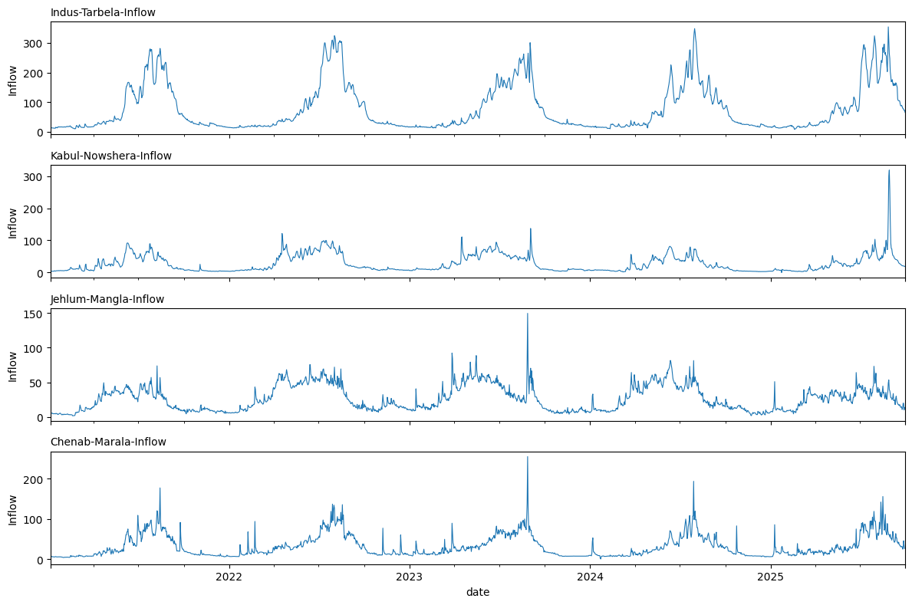
Figure 1: Daily inflow of the four rivers, 2021–2025
Observation: Every year the rivers rise in summer and fall in winter. The Kabul River has one huge spike in late August 2025 (318), more than double its highest value in earlier years (137). Marala and Mangla have their biggest spikes in September 2023.

2. Problem Definition
Question: “Using the river data up to today, how much water will arrive tomorrow (and up to 5 days ahead)?”
- Kabul River at Nowshera: the river of Paper 8.
- Chenab River at Marala: the river of Paper 7.
- Data cleaning: the year was rebuilt, repeated dates were removed, and 5 missing days were filled. We dropped 4 columns: “Total inflows” is just the sum of the four rivers (a copy), and “last year” and “10-year average” are only comparison numbers.
No leakage: The inputs only use information up to today, and the answer is always in the future. The scaling used by the LSTM was learned from the training years only.

3. Experimental Setup and Models
- Study (training): 2021–2023, 1,086 days. Exam (testing): January 2024 to September 2025, 638 days.
- Inputs (12): the 8 river and dam columns of today, yesterday’s and 2-days-ago inflow of the river we forecast, its 3-day average, and the month.

Model | Simple explanation
Baseline | “Tomorrow will be the same as today.” The simplest guess. Every model must beat this.
Linear Regression | Finds the best straight-line rule from the inputs.
Random Forest | 300 decision trees; the answer is their average.
XGBoost | Trees built one after another; each fixes the mistakes of the earlier ones.
LSTM | Deep-learning model with memory; it reads the last 7 days.

4. Evaluation Metrics
Here we predict a number (water amount), not “flood / no flood”, so we use these scores:
Metric | Meaning in simple words | Good value
R² | How much of the up-and-down pattern of the river the model catches. 1 = perfect, 0 = no better than a plain average. | Close to 1
RMSE | The typical size of the mistake. Big mistakes are punished more. | Small
MAE | The average size of the mistake, in the same units as the inflow. | Small

Simple words: If the MAE is 3, the forecast is wrong by about 3 units on an average day. The RMSE becomes much bigger than the MAE when the model makes a few very big mistakes, for example when it misses a flood peak.

5. Results: Forecast for Tomorrow
River | Model | R² | RMSE | MAE
Kabul (Nowshera) | Baseline (same as today) | 0.902 | 9.2 | 3.2
 | Linear Regression | 0.925 | 8.1 | 3.4
 | Random Forest | 0.711 | 15.8 | 4.0
 | XGBoost | 0.705 | 16.0 | 4.4
 | LSTM | 0.566 | 19.4 | 8.2
Chenab (Marala) | Baseline (same as today) | 0.819 | 11.5 | 5.3
 | Linear Regression | 0.847 | 10.5 | 5.7
 | Random Forest | 0.835 | 11.0 | 5.9
 | XGBoost | 0.831 | 11.1 | 6.5
 | LSTM | 0.835 | 11.0 | 6.5

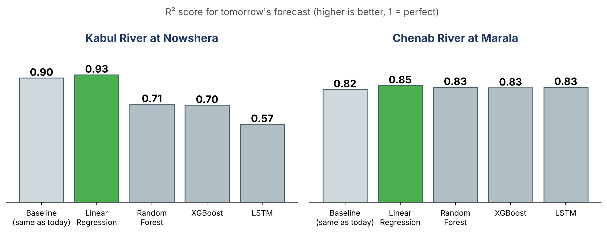
Figure 2: R² of each model (green = best)
Observation: Linear Regression is the best on both rivers (R² 0.93 and 0.85), but only slightly better than the simple baseline. For the Kabul River, Random Forest, XGBoost and LSTM are clearly worse than the baseline. On the Chenab, all models are close to each other (0.82 to 0.85). The LSTM has the largest average mistake on the Kabul River (MAE 8.2).

6. The Big Flood of August 2025 (Kabul River)
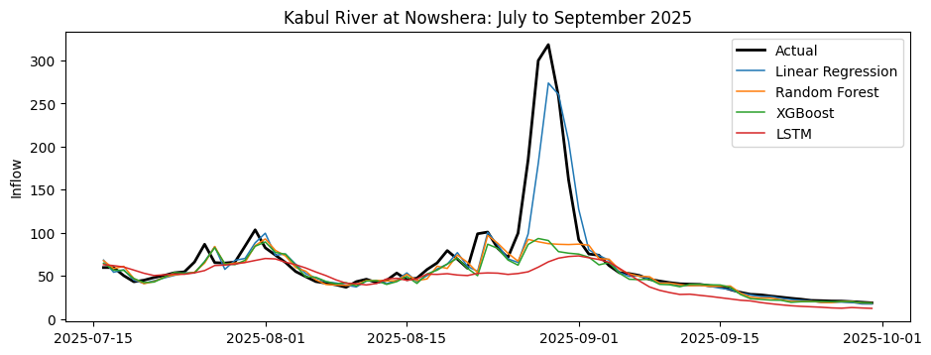
Figure 3: Kabul River at Nowshera, July to September 2025 (black = actual)
Observation: The actual peak (318) is much higher than anything in the training years (137). Random Forest, XGBoost and LSTM predicted only about 80 to 97, because they cannot predict values far bigger than what they have already seen. Linear Regression reached 274, but its line rises about a day after the real rise, because it mostly copies yesterday’s value.

 | Highest value
Actual inflow in August 2025 | 318.5
Highest inflow in the training years (2021–2023) | 137.2
Linear Regression predicted | 273.8
Random Forest predicted | 96.9
XGBoost predicted | 93.3
LSTM predicted | 79.0

7. Forecasting 1 to 5 Days Ahead
Days ahead | Kabul: Baseline | Kabul: Linear | Chenab: Baseline | Chenab: Linear
1 | 0.902 | 0.925 | 0.819 | 0.847
2 | 0.697 | 0.749 | 0.731 | 0.774
3 | 0.497 | 0.595 | 0.698 | 0.731
4 | 0.365 | 0.503 | 0.659 | 0.696
5 | 0.298 | 0.457 | 0.620 | 0.671

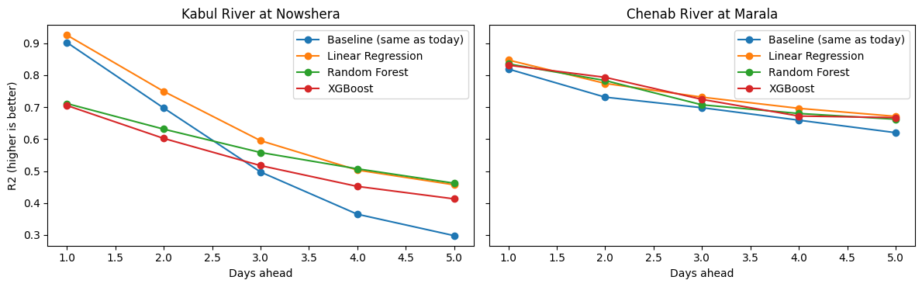
Figure 4: R² for 1 to 5 days ahead
Observation: Every line goes down: the further ahead we forecast, the worse the score (Kabul falls from 0.93 to 0.46 with Linear Regression). This is similar to Paper 8, where forecasts were good only for a few days. Models help most at 4 to 5 days: for the Kabul River Linear Regression scores 0.50 and 0.46 against 0.37 and 0.30 for the baseline.

8. LSTM Training and Important Inputs
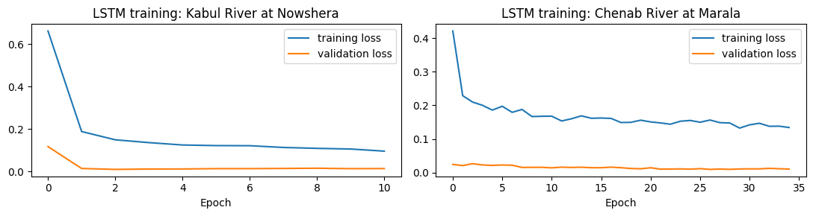
Figure 5: LSTM training curve
Observation: The training stopped by itself after about 10 rounds for Kabul and 35 for Chenab. The orange (new data) line stays below the blue line, so there is no sign of memorising. The LSTM is weak on the Kabul River for another reason: it cannot predict a flood bigger than the ones it has seen.

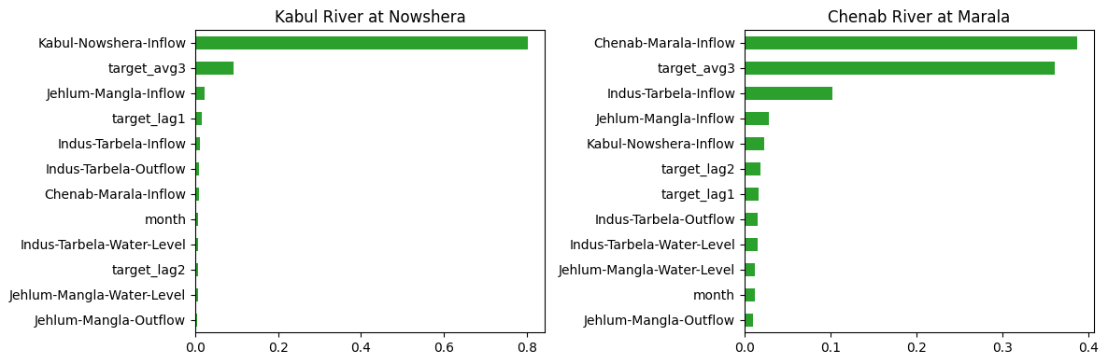
Figure 6: XGBoost input importance
Observation: A longer bar means the model used that input more. XGBoost mostly uses today’s inflow of the same river (Kabul about 0.8; Chenab about 0.4 plus the 3-day average about 0.36). Other rivers and dams have little effect.

9. Limitations
- Only river and dam data: no rainfall, satellite or weather data. The river only shows the flood after the water has started to rise.
- Daily values only, and only 4 river points.
- The year of each date was rebuilt by us, and the units are not given in the dataset.
- The biggest flood is in the test period only, so the models never learned from such a big event.

10. Conclusion and Link to My Thesis
- We used daily river data (2021 to September 2025) to forecast the inflow of the Kabul River and the Chenab River.
- Linear Regression was the best, but only slightly better than “tomorrow = today”. River flow changes slowly, so complex models did not help.
- Forecasts get worse after 2 to 3 days, and most models missed the very big Kabul flood of August 2025. So river data alone is not enough for early warning.
- My thesis adds satellite rainfall, weather and terrain data to warn hours earlier for flash floods in KP and Balochistan.

